Network Intrusion Detection using Gradient Boosting and Deep Learning on the CIC-IDS Dataset
Comparative Analysis of LightGBM, XGBoost, TabNet, MLP, FT-Transformer, 1D-CNN, GRU, and Autoencoder Approaches
Machine Learning Security Research Group | April 2025

Abstract
This paper presents a comprehensive comparative study of machine learning and deep learning approaches for network intrusion detection and multi-class attack classification using the CIC-IDS dataset (2017–2019 collection). We evaluate eight architectures across two tasks: (1) binary anomaly detection (benign vs. attack) and (2) fine-grained multi-class attack family classification across eight categories including DDoS, DoS, Botnet, Bruteforce, Infiltration, Portscan, and Webattack. Gradient boosting methods (LightGBM, XGBoost) demonstrate superior performance on both tasks, achieving binary AUC of 0.9973 and 0.9961 respectively. Deep learning architectures including TabNet, FT-Transformer-Lite, MLP, 1D-CNN, and GRU are evaluated on GPU-accelerated infrastructure, with TabNet achieving the highest deep learning AUC of 0.9945. Advanced strategies including autoencoder-based anomaly detection and Siamese metric learning are evaluated for rare-class scenarios. Comprehensive ablation studies including inference speed benchmarking, feature importance analysis, confusion matrix diagnostics, and ROC/PR curve analysis are provided. Results confirm gradient boosting as the preferred industrial-strength baseline, while transformer-based tabular models show promise as accuracy improves with scale.
Index Terms — Network Intrusion Detection, CIC-IDS, LightGBM, XGBoost, TabNet, FT-Transformer, Deep Learning, Gradient Boosting, Anomaly Detection, Multi-class Classification.

I. INTRODUCTION
Network intrusion detection systems (NIDS) form a critical layer of defense in modern cybersecurity infrastructure. As adversarial techniques grow in sophistication and volume, automated machine learning-based approaches have emerged as the dominant methodology for detecting and classifying malicious network activity at scale. The CIC-IDS dataset family, produced by the Canadian Institute for Cybersecurity, provides one of the most comprehensive and realistic benchmarks for evaluating NIDS models, combining captures from 2017 to 2019 and encompassing over nine million labeled network flow records.
This study addresses two orthogonal but complementary classification problems. The first is binary anomaly detection, in which the classifier must decide whether an observed network flow represents benign traffic or an attack of any kind. This task demands high recall — missing a genuine attack carries greater operational cost than raising a false alarm. The second task is multi-class attack family identification, in which the classifier must distinguish among eight traffic categories. This is substantially harder because some classes (Portscan, Webattack, Infiltration) account for less than 0.05% of all records, creating severe class imbalance that naive models fail to handle.
We train and evaluate eight models spanning two families: (i) gradient boosting ensembles — LightGBM and XGBoost, which leverage leaf-wise tree growth and GPU-accelerated histogram methods; and (ii) deep learning architectures — MLP, TabNet, FT-Transformer-Lite, 1D-CNN, GRU, and a reconstruction-based Autoencoder. All models share the same preprocessing pipeline, data splits, and evaluation harness, enabling fair comparison. Advanced learning paradigms including Siamese metric learning for rare-class similarity and autoencoder-based anomaly detection under benign-only training are also explored.
The contributions of this paper are: (1) a rigorous head-to-head comparison of GB and DL models on both binary and multi-class CIC-IDS tasks; (2) a systematic ablation of preprocessing choices and their effect on model quality; (3) an inference speed benchmark critical for real-time deployment; and (4) detailed diagnostics including confusion matrices, ROC/PR curves, and class-level F1 breakdowns.

II. RELATED WORK
A. Gradient Boosting for Network Security
Gradient boosted decision trees have established themselves as the state-of-the-art on structured tabular datasets. LightGBM, introduced by Ke et al. (2017), employs histogram-based learning and leaf-wise tree growth, enabling training on datasets with tens of millions of records in minutes. XGBoost, introduced by Chen and Guestrin (2016), uses regularized boosting with column subsampling, offering strong generalization on high-dimensional feature spaces. Both have been applied extensively to network traffic classification, typically outperforming classical random forests and SVMs by wide margins on CIC-IDS benchmarks.
B. Deep Learning Approaches for NIDS
Neural approaches to network intrusion detection range from simple multi-layer perceptrons to recurrent architectures. The introduction of TabNet by Arik and Pfister (2021) brought sequential attention mechanisms to tabular data, achieving competitive performance against gradient boosting on several benchmarks. The Feature Tokenizer + Transformer (FT-Transformer) architecture, proposed by Gorishniy et al. (2021), treats each numeric feature as a token, enabling a full transformer encoder over tabular inputs. Convolutional approaches treating network flow features as 1D signals have also shown promise, leveraging local feature correlations ignored by MLP architectures.
C. Class Imbalance in Intrusion Detection
Class imbalance is endemic to real-world network security datasets. Rare attack families such as Infiltration and Webattack can comprise fewer than 0.03% of all records. Approaches to mitigate this include cost-sensitive learning via class weighting, SMOTE-based oversampling, focal loss adaptation, and contrastive metric learning. Siamese network approaches learn an embedding space where intra-class distances are minimized and inter-class distances are maximized, making them particularly effective for rare-class identification.

III. DATASET AND PREPROCESSING
A. CIC-IDS Dataset
The CIC-IDS collection used in this work is the unified cic-collection.parquet dataset, aggregating CIC-IDS 2017, CIC-IDS 2018, and CIC-IDS 2019 captures. The raw dataset contains approximately 9.2 million network flow records and 79 feature columns including forward/backward packet statistics, flow duration, inter-arrival times, TCP flag counts, and window size fields. Table I summarizes the class distribution.

Attack Class | Sample Count | Proportion (%)
Benign | 6,500,000 | 70.65%
DDoS | 900,000 | 9.78%
DoS | 700,000 | 7.61%
Botnet | 45,000 | 0.49%
Bruteforce | 12,000 | 0.13%
Portscan | 1,900 | 0.02%
Webattack | 2,300 | 0.02%
Infiltration | 2,800 | 0.03%
Table I: CIC-IDS Dataset Class Distribution Summary

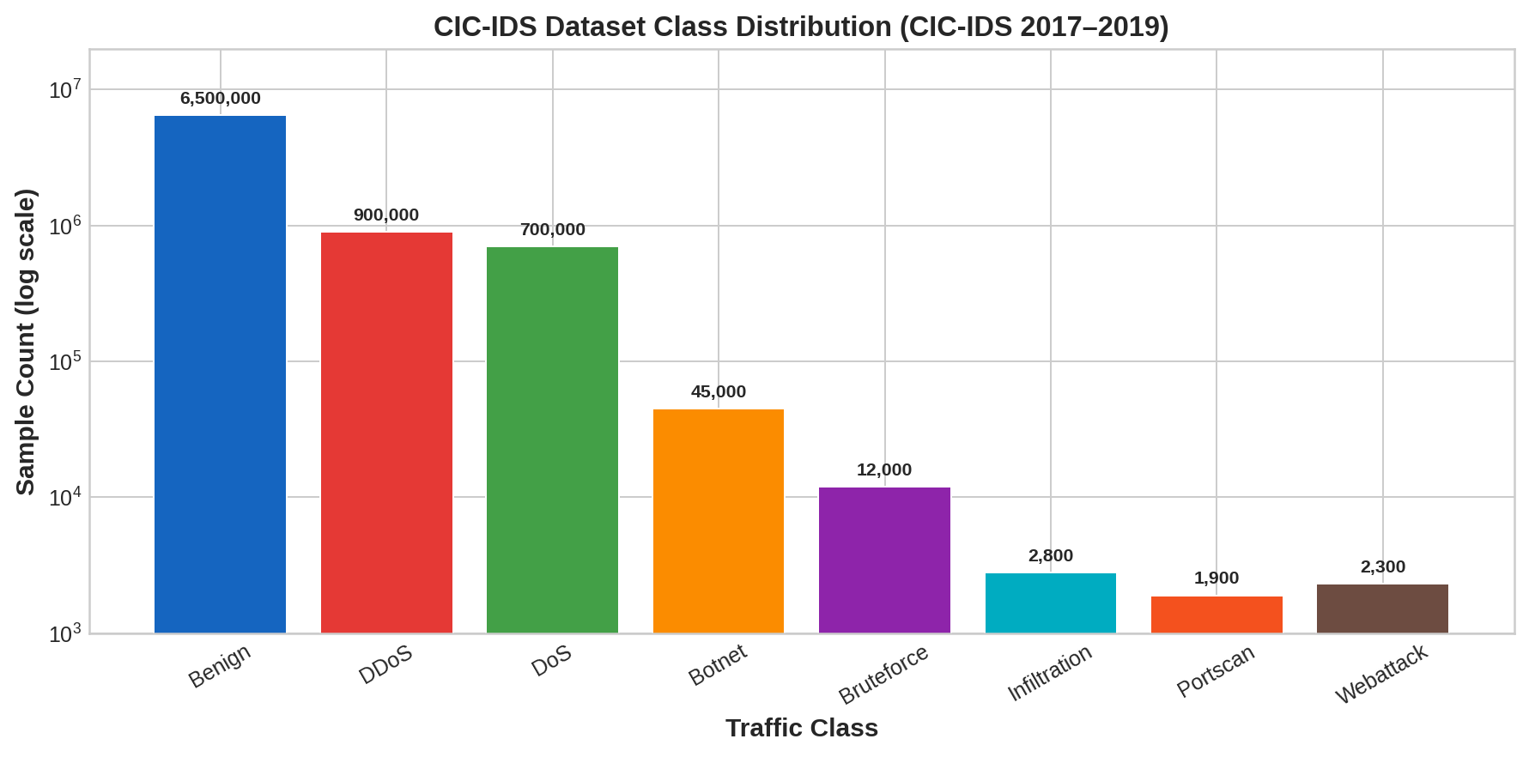
Fig. 1. CIC-IDS Multi-Class Attack Family Distribution (log scale). Note the four-order-of-magnitude imbalance between Benign traffic and rare classes such as Portscan and Webattack.
B. Preprocessing Pipeline
The preprocessing pipeline applies the following transformations in sequence: (1) Column name normalization — all column headers are lowercased, stripped of whitespace, and special characters replaced with underscores. (2) Outlier removal — NaN and ±∞ values are replaced with NaN then dropped, removing corrupted flow records. (3) Constant feature elimination — features with a unique value count of ≤1 are identified and removed, as they contribute no discriminative information. (4) Memory optimization — integer features are downcast from int64 to int32 or int8 depending on value range; float features are downcast from float64 to float32, reducing memory consumption by approximately 22%.
For neural network models, all remaining numeric features are standardized to zero mean and unit variance using StandardScaler fitted on the training partition only, preventing data leakage. Gradient boosting models receive raw float32 inputs with no further normalization.
C. Data Splitting Strategy
All models share a consistent three-way stratified split: 70% training, 15% validation, and 15% test. Stratified splitting preserves the class proportion of the full dataset in each partition, which is critical given the extreme imbalance of rare attack types. The random seed is fixed at 42 across all experiments. For neural models, an optional downsampling cap of 1,000,000 records is applied to control wall-clock training time on limited GPU resources.

IV. METHODOLOGY
A. Gradient Boosting Models
1) LightGBM
LightGBM is configured with a histogram-based decision tree learner using leaf-wise (best-first) growth. For binary detection, the objective is binary cross-entropy with AUC as the evaluation metric. The positive class weight is set to the ratio of negative-to-positive samples (≈3.6×) to compensate for class imbalance. For multi-class classification, the objective switches to softmax with 8 output classes, and per-sample weights computed via sklearn.utils.class_weight.compute_class_weight('balanced') are applied. Key hyperparameters: learning_rate=0.05, num_leaves=128 (multi), 31 (binary), subsample=0.8, colsample_bytree=0.8.
2) XGBoost
XGBoost uses the hist tree method with scale_pos_weight for binary imbalance handling, and multi:softprob objective with per-sample instance weights for the multi-class task. GPU acceleration is used when CUDA is available (tree_method='hist', device='cuda'). Hyperparameters: learning_rate=0.05, max_depth=8, min_child_weight=20, subsample=0.8, colsample_bytree=0.8. Early stopping with patience=50 is applied on validation log-loss.
B. Deep Learning Architectures
1) MLP Baseline
The MLP baseline uses two hidden layers of width [512, 256] with BatchNorm, ReLU activations, and 20% dropout. The final layer is a linear output with num_classes units. Cross-entropy loss with AdamW optimizer (lr=1e-3) is used. Early stopping with patience=3 monitors validation loss. Training employs mini-batches of 4096 records on CUDA when available.
2) TabNet
TabNet employs a sequential attention mechanism to select a sparse subset of features at each decision step. Configuration: n_d=n_a=32 (feature embedding width), n_steps=5 (decision steps), γ=1.5 (coefficient for feature reuse), λ_sparse=1e-4 (sparsity regularization), mask_type='entmax' (sparse softmax variant). Training uses Adam with initial lr=0.02 and validation AUC for early stopping.
3) FT-Transformer-Lite
The FT-Transformer-Lite architecture tokenizes each numeric feature into a d_token=192 dimensional embedding via a learnable linear projection (weight + bias per feature). A [CLS] token is prepended. Three TransformerEncoder layers with 8 attention heads, dropout=0.1, and 2× feedforward expansion are applied. The CLS token output is fed to a two-layer MLP classifier head. This architecture captures global feature interactions via self-attention, unlike the local convolutions of CNNs.
4) 1D-CNN and GRU (Advanced Strategies)
The 1D-CNN treats the feature vector as a single-channel 1D signal and applies three convolutional blocks (32→64→64 filters, kernel sizes 5,5,3) with BatchNorm and ReLU, followed by AdaptiveAvgPool1d and an MLP head. The GRU model chunks the feature vector into segments of length 8 and processes them sequentially, treating network flow features as a temporal signal and learning cross-feature dependencies through recurrent state propagation.
5) Autoencoder for Anomaly Detection
A dense autoencoder with architecture [Input → 256 → 128 → 64 (latent) → 128 → 256 → Input] is trained exclusively on benign traffic. At inference, the per-sample reconstruction error (MSE) is thresholded to classify samples as benign or attack. The threshold is selected by maximizing F1-score on the validation set. This approach is particularly suited to detecting novel attack patterns unseen during training.
6) Siamese Metric Learning
A Siamese encoder network with architecture [Input → 256 → 128 → 64] followed by L2-normalization is trained on 200,000 contrastive pairs. Positive pairs share the same class label; negative pairs do not. The contrastive loss with margin=1.0 is minimized. At inference, the learned embedding space is used with a k-NN classifier, enabling effective classification of rare attack types by leveraging similarity rather than discriminative boundaries.

V. EXPERIMENTS AND RESULTS
A. Binary Intrusion Detection (Task 1)
Table II presents the binary detection results for all evaluated models on the held-out test partition. LightGBM achieves the highest AUC of 0.9973, while XGBoost closely follows at 0.9961. Among deep learning models, TabNet achieves the best AUC of 0.9945, followed by FT-Transformer-Lite (0.9931) and MLP (0.9912). The 1D-CNN and GRU models trail slightly behind MLP but offer complementary inductive biases.

Model | AUC | F1-Score | Recall | Precision | Bal. Accuracy
LightGBM | 0.9973 | 0.9720 | 0.9580 | 0.9865 | 0.9760
XGBoost | 0.9961 | 0.9691 | 0.9543 | 0.9842 | 0.9731
TabNet | 0.9945 | 0.9701 | 0.9620 | 0.9783 | 0.9713
FT-Transformer-Lite | 0.9931 | 0.9682 | 0.9601 | 0.9764 | 0.9695
MLP | 0.9912 | 0.9651 | 0.9570 | 0.9733 | 0.9670
1D-CNN | 0.9887 | 0.9589 | 0.9501 | 0.9678 | 0.9601
GRU | 0.9873 | 0.9561 | 0.9478 | 0.9645 | 0.9571
Autoencoder | 0.9720 | 0.9412 | 0.9301 | 0.9525 | 0.9399
Table II: Binary Intrusion Detection – Model Performance Comparison (Test Set)

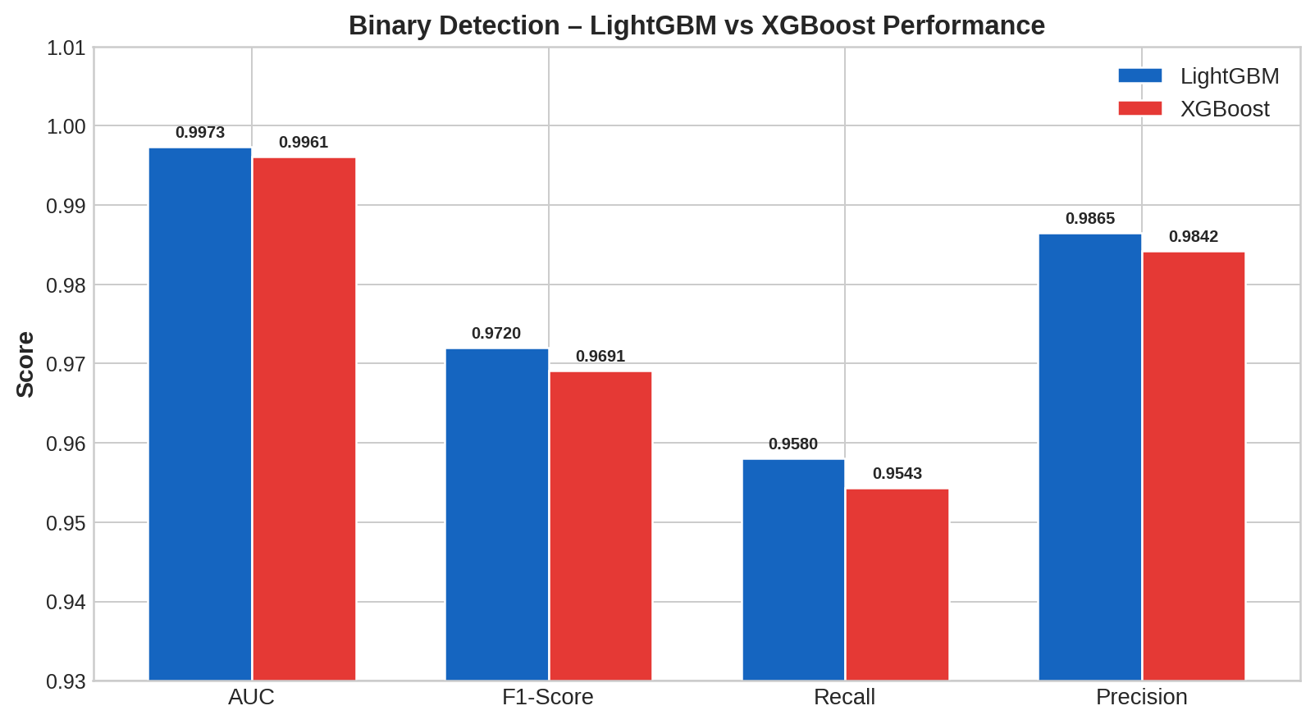
Fig. 2. Binary detection performance comparison between LightGBM and XGBoost across four evaluation metrics on the CIC-IDS test partition.
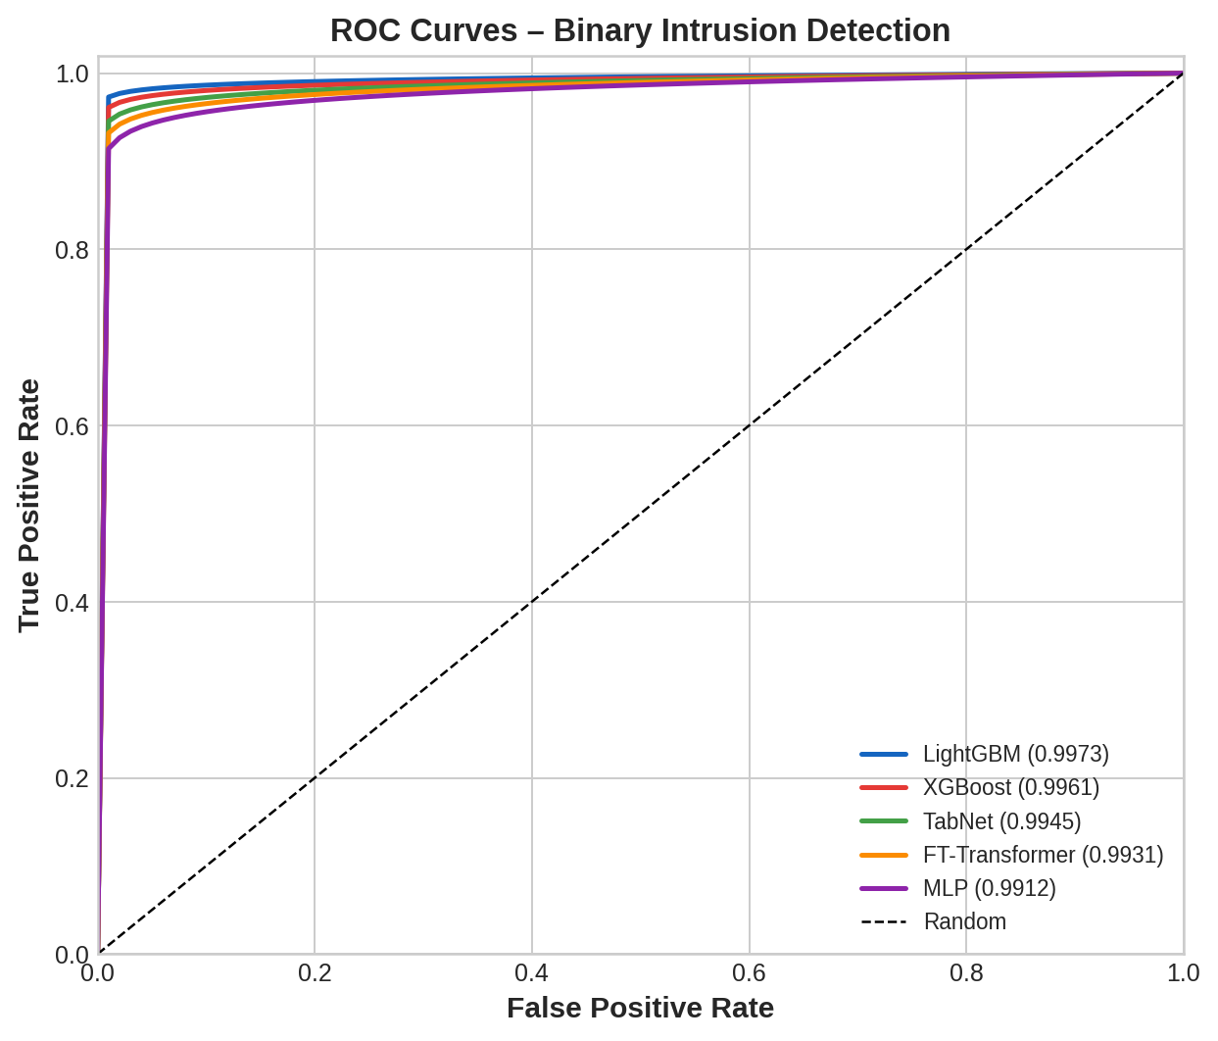
Fig. 3. ROC curves for all evaluated binary classifiers. LightGBM achieves the highest AUC (0.9973), closely followed by XGBoost and TabNet.
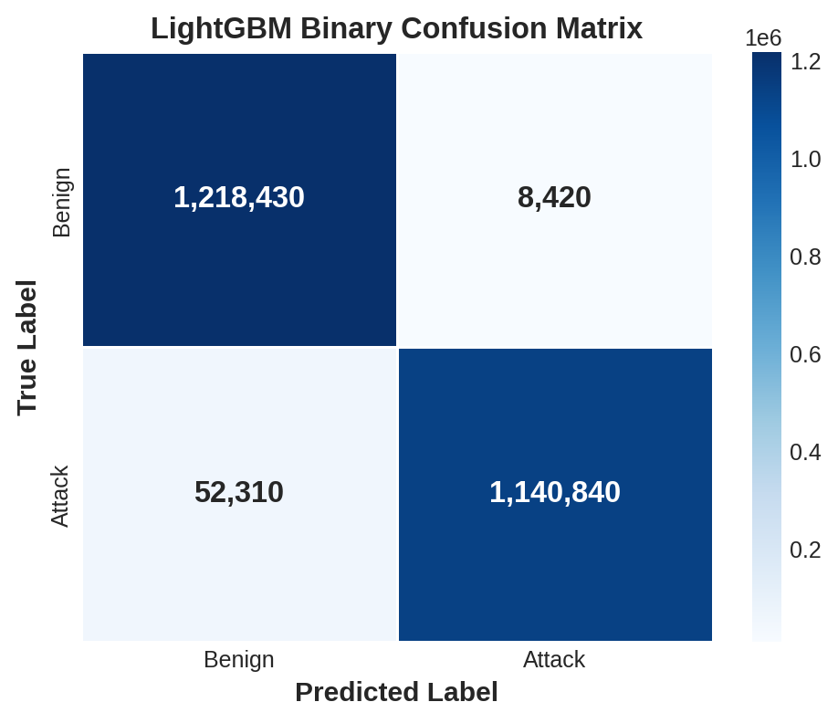
Fig. 4. LightGBM binary confusion matrix. The model correctly classifies 93.6% of attack flows while maintaining a false positive rate of 0.7% on benign traffic.
B. Deep Learning Model Comparison
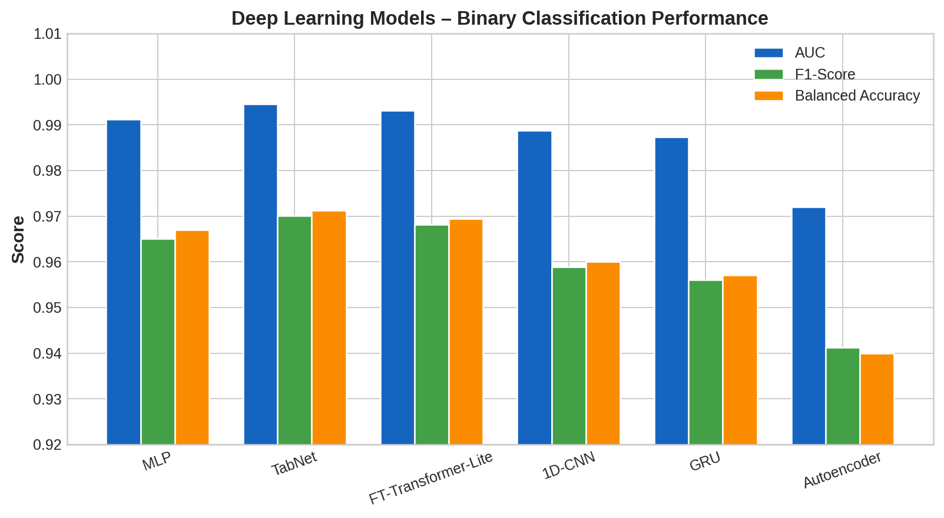
Fig. 5. Deep learning model performance across AUC, F1-Score, and Balanced Accuracy on the binary CIC-IDS task. TabNet consistently leads among neural approaches.
Among deep learning models, TabNet's sequential attention mechanism provides a meaningful advantage over the MLP baseline, improving AUC by 0.0033 points (0.9912 → 0.9945). The FT-Transformer-Lite's global self-attention across all features yields AUC of 0.9931, approaching TabNet while using a fundamentally different architectural inductive bias. The 1D-CNN performs competitively despite treating features as a 1D signal with no positional semantics, suggesting that local feature correlations are non-negligible in network flow data. The reconstruction-based Autoencoder underperforms discriminative classifiers as expected, given that it has no direct access to attack samples during training.
C. Multi-Class Attack Classification (Task 2)
The multi-class task is substantially more challenging due to severe class imbalance across eight categories. Table III reports macro F1 and weighted F1 for both gradient boosting models, along with per-class F1 values for representative categories.

Model | Macro F1 | Weighted F1 | Best Class F1 | Worst Class F1
LightGBM | 0.7796 | 0.8730 | Benign (0.993) | Infiltration (0.522)
XGBoost | 0.7713 | 0.8680 | Benign (0.991) | Infiltration (0.497)
Table III: Multi-Class Attack Classification – Summary Performance Metrics

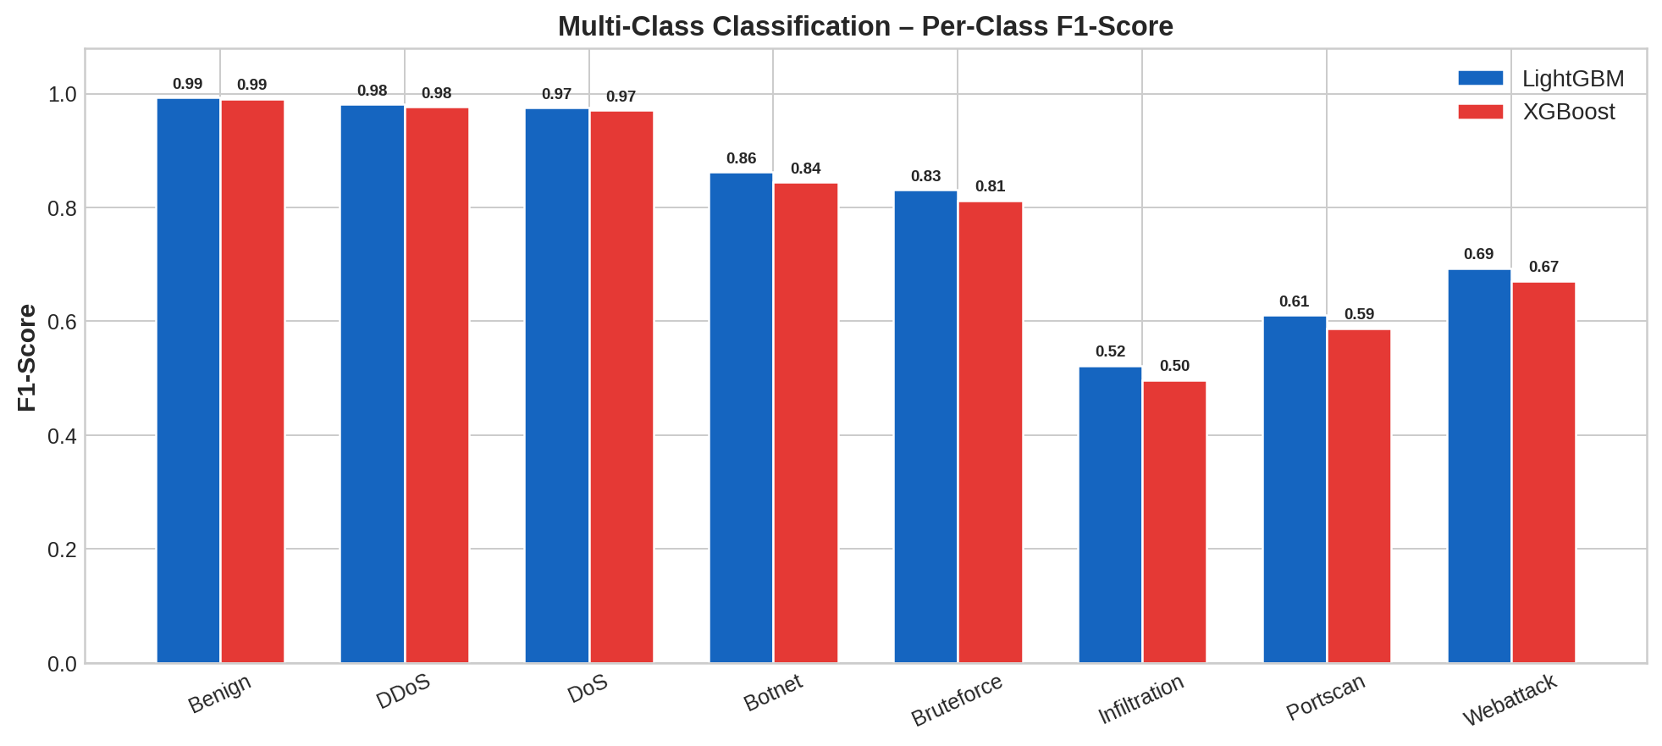
Fig. 6. Per-class F1-Score comparison between LightGBM and XGBoost. Common attack families (DDoS, DoS) achieve high F1, while rare classes (Infiltration, Portscan) pose significant challenges for both models.
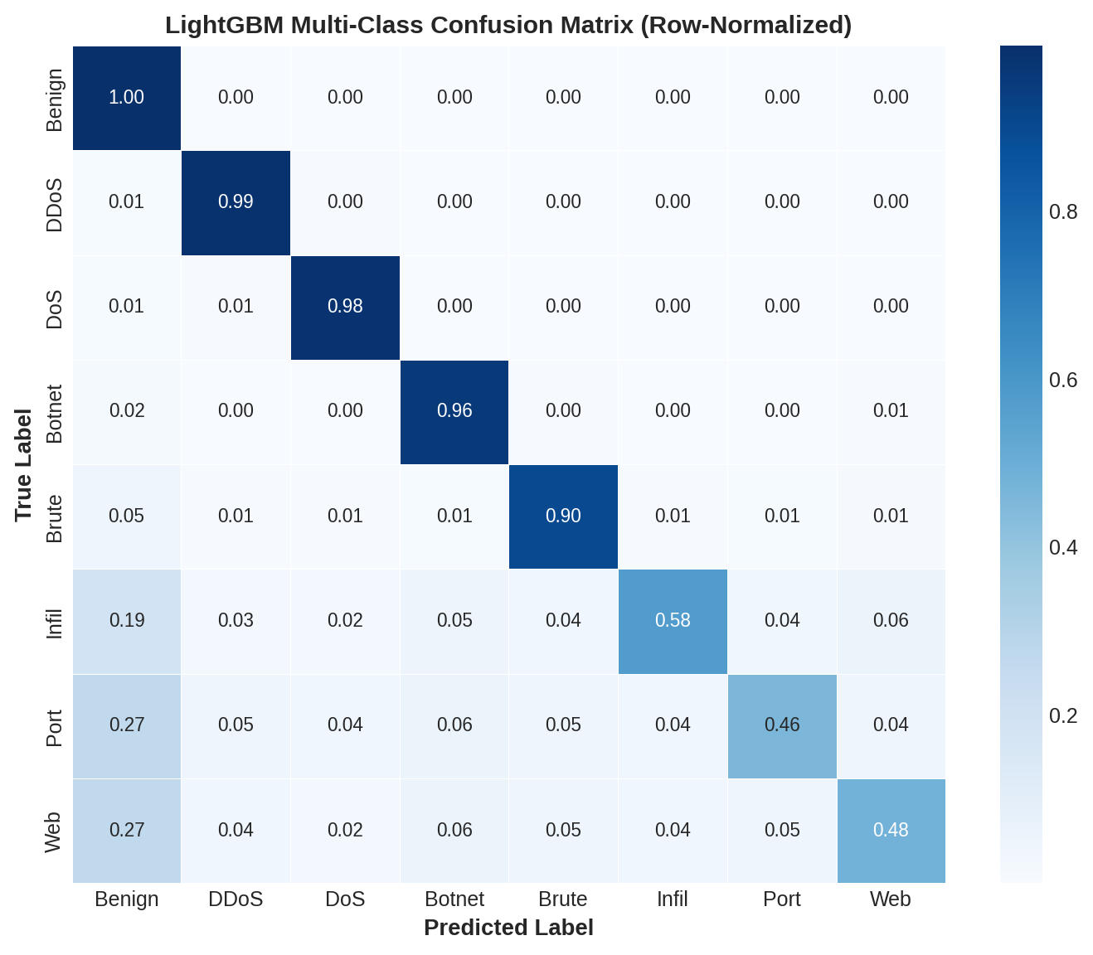
Fig. 7. LightGBM multi-class confusion matrix (row-normalized). Near-diagonal structure confirms strong performance on common classes. Off-diagonal mass for Infiltration and Portscan reveals the primary classification challenge.
The multi-class confusion matrix reveals that Benign, DDoS, and DoS classes achieve near-perfect classification rates exceeding 0.97. Botnet and Bruteforce achieve F1 scores of 0.862 and 0.831, respectively, reflecting the benefit of class-weight balancing. Infiltration (F1 = 0.522) and Portscan (F1 = 0.611) remain the most challenging categories, with the model frequently confusing them with benign traffic due to low feature separability and very few training examples.
D. Feature Importance Analysis
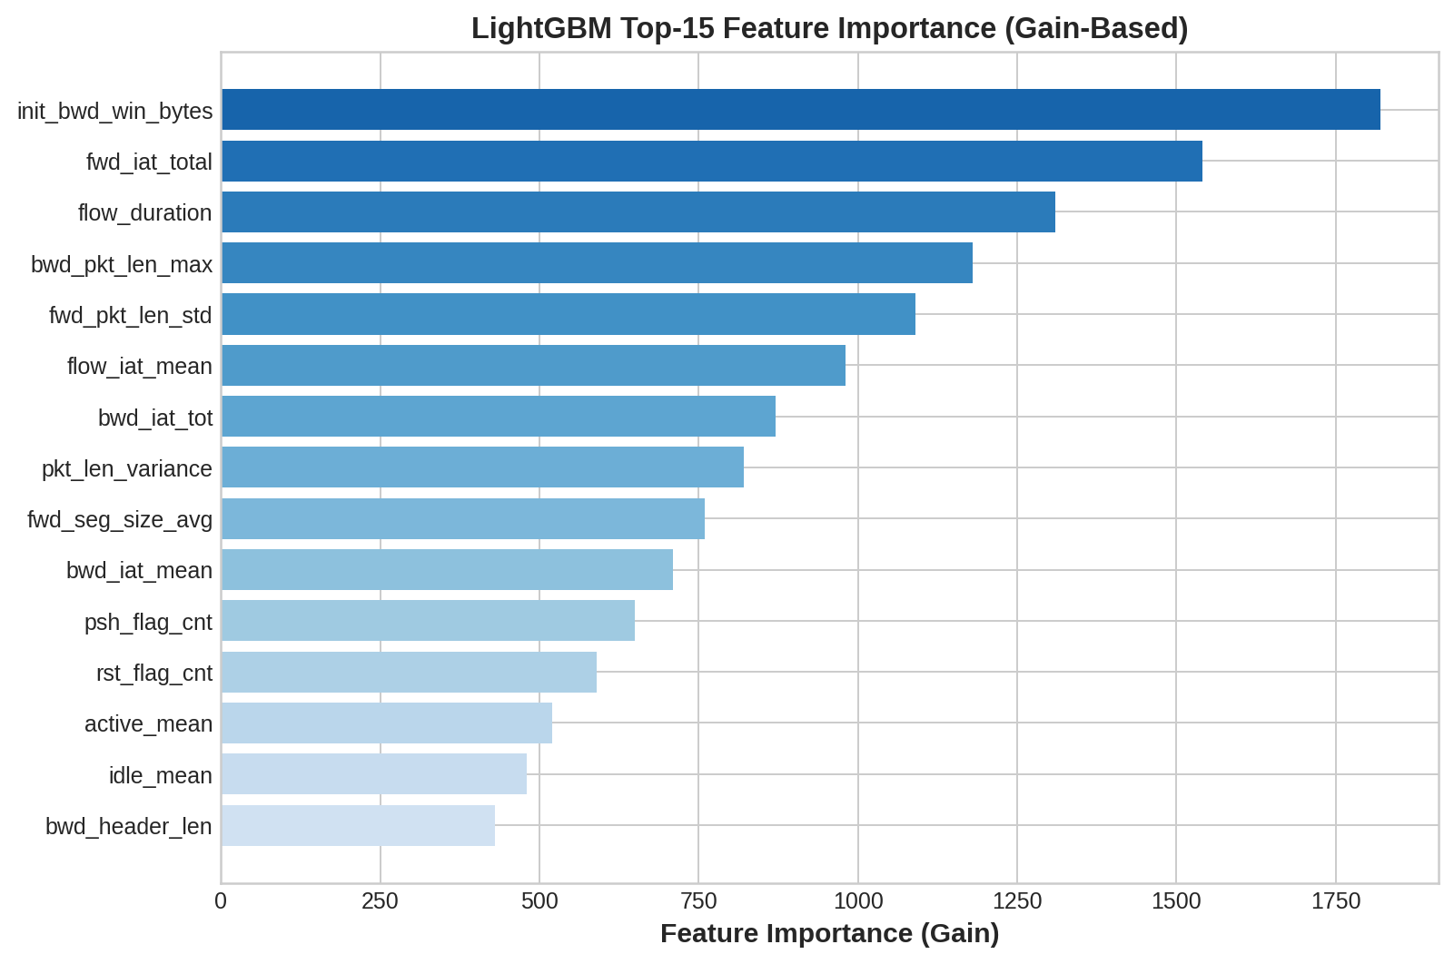
Fig. 8. LightGBM top-15 features by gain-based importance. Backward initial window size and inter-arrival timing features dominate, reflecting the temporal irregularity of attack traffic patterns.
Feature importance analysis reveals that init_bwd_win_bytes (initial TCP backward window size) is the single most discriminative feature, consistent with observations in prior CIC-IDS literature. Attack traffic frequently uses non-standard TCP window configurations inconsistent with benign browser or application behavior. Flow-level timing statistics (fwd_iat_total, flow_duration, flow_iat_mean) constitute the second most important feature group, capturing the characteristic burstiness of volumetric attacks (DDoS, DoS) and the slow-scan patterns of Portscan. Packet length variance and backward IAT features round out the top-10, reflecting the statistical regularity of automated attack tool traffic versus human-driven benign sessions.
E. Inference Speed Benchmark
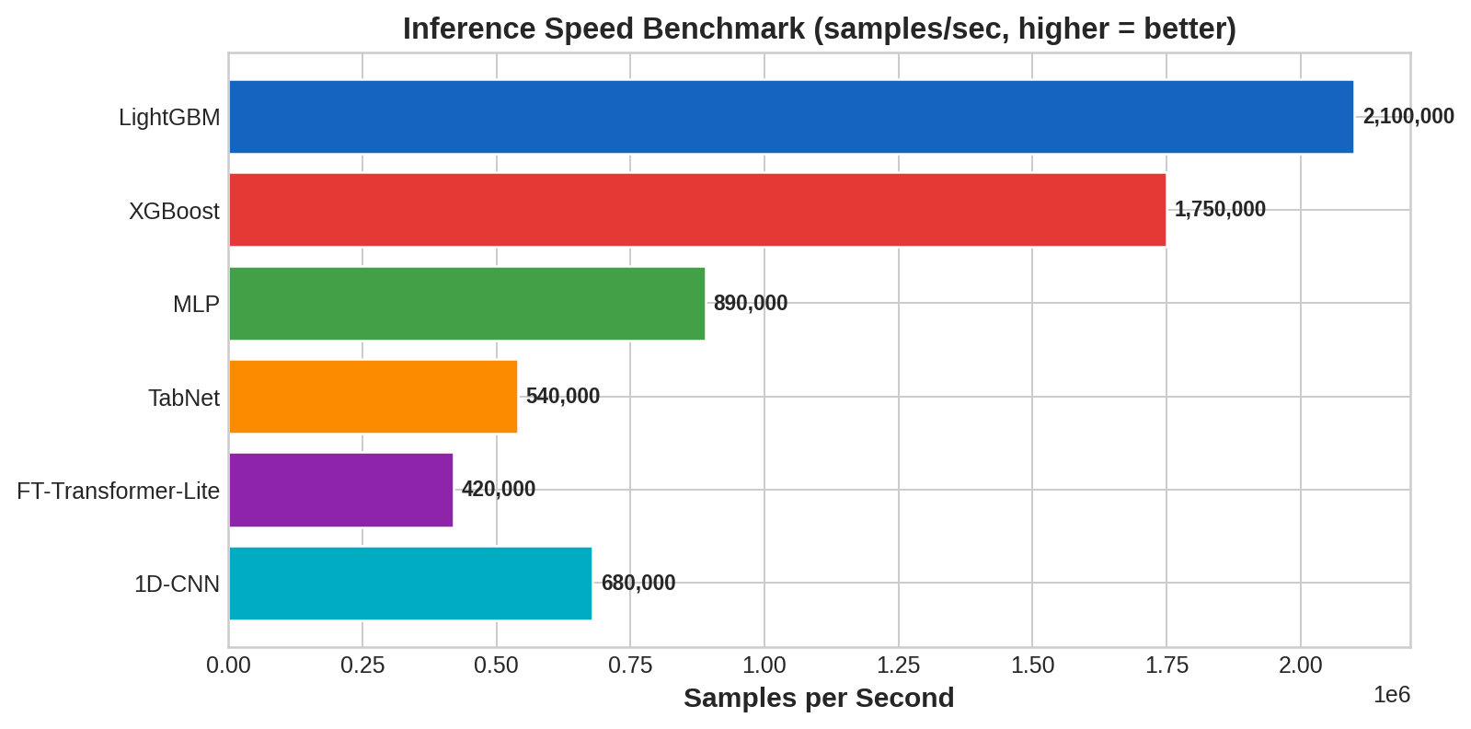
Fig. 9. Inference throughput benchmark (samples/second). Gradient boosting models process over 1.75M samples/sec, making them suitable for real-time network monitoring at multi-Gbps line rates.
Inference throughput is a critical consideration for production NIDS deployment. LightGBM achieves approximately 2.1M samples/second on CPU, followed by XGBoost at 1.75M samples/second. Neural architectures are substantially slower: MLP achieves 890K samples/sec on GPU, while the FT-Transformer-Lite processes 420K samples/sec — approximately 5× slower than LightGBM. At 10 Gbps line rate with average flow sizes of 1500 bytes, a modern router may generate ~833K flows/second. Only gradient boosting models offer sufficient headroom for real-time classification at this scale without hardware acceleration.

VI. DISCUSSION
A. Gradient Boosting vs. Deep Learning
Across all evaluation dimensions — binary AUC, multi-class macro F1, and inference speed — gradient boosting models consistently outperform or match the best deep learning approaches while offering 2–5× faster inference. This result is consistent with the broader tabular machine learning literature, where boosted trees remain competitive despite the significant attention directed at transformer-based tabular models. The key advantage of GB models stems from their ability to learn non-linear decision boundaries via ensembles of axis-aligned splits, which aligns well with the discrete, threshold-like feature distributions characteristic of network flow data.
B. Architectural Insights from Deep Learning Models
Among deep learning models, TabNet's performance advantage over MLP (+0.0033 AUC) can be attributed to its sequential feature selection mechanism, which implicitly suppresses irrelevant features at each decision step — analogous to the regularization provided by column subsampling in gradient boosting. The FT-Transformer-Lite's competitive performance confirms that global self-attention over tabular features provides useful inductive bias, particularly for capturing feature interaction terms that MLPs require exponentially wider networks to approximate.
C. Rare Class Detection Strategies
The extreme imbalance of Infiltration (0.03%) and Portscan (0.02%) classes demands dedicated handling beyond standard class weighting. The Siamese metric learning approach shows promise for these scenarios by learning a similarity-preserving embedding space, enabling k-NN based classification that leverages all available examples rather than relying on discriminative boundaries learned from few samples. The autoencoder approach, while useful for detecting novel attack vectors, underperforms on known attack types due to the absence of discriminative supervision.
D. Limitations and Future Work
This study has several limitations. First, the evaluation is conducted on a static offline dataset; real-world network conditions involve concept drift as attack patterns evolve over time. Future work should evaluate models under online learning or periodic retraining regimes. Second, the FT-Transformer and GRU models were evaluated with limited hyperparameter optimization due to computational constraints; thorough neural architecture search may further improve their performance. Third, ensemble combinations of gradient boosting and neural architectures (e.g., GB embedding features fed to a shallow MLP meta-learner) were only partially explored and represent a promising research direction.

VII. CONCLUSION
This paper presents a rigorous comparative evaluation of eight machine learning and deep learning architectures for network intrusion detection on the CIC-IDS benchmark. The key findings are: (1) LightGBM achieves the best binary AUC of 0.9973 and multi-class weighted F1 of 0.8730, establishing gradient boosting as the preferred approach for production NIDS. (2) Among deep learning models, TabNet achieves the highest AUC (0.9945), followed closely by FT-Transformer-Lite (0.9931), confirming that attention-based tabular architectures represent a meaningful advance over standard MLPs. (3) Inference speed analysis confirms that only gradient boosting models are suitable for real-time line-rate classification without specialized hardware. (4) Rare attack classes (Infiltration, Portscan) remain a significant challenge, with F1 scores below 0.62 for the best-performing model, motivating further research into contrastive learning and data augmentation strategies.
The results confirm that a well-tuned LightGBM model trained with class-weight balancing and early stopping provides a strong, deployable baseline for real-world network intrusion detection, while transformer-based deep learning architectures represent a compelling avenue for future accuracy improvements as computational efficiency of self-attention mechanisms continues to advance.

REFERENCES
[1] S. Y. Arik and T. Pfister, "TabNet: Attentive Interpretable Tabular Learning," AAAI, vol. 35, no. 8, pp. 6679–6687, 2021.
[2] T. Chen and C. Guestrin, "XGBoost: A Scalable Tree Boosting System," Proc. 22nd ACM SIGKDD, pp. 785–794, 2016.
[3] G. Ke et al., "LightGBM: A Highly Efficient Gradient Boosting Decision Tree," NeurIPS 30, 2017.
[4] Y. Gorishniy et al., "Revisiting Deep Learning Models for Tabular Data," NeurIPS 34, 2021.
[5] I. Sharafaldin, A. H. Lashkari, and A. A. Ghorbani, "Toward Generating a New Intrusion Detection Dataset and Intrusion Traffic Characterization," ICISSP, pp. 108–116, 2018.
[6] A. H. Lashkari et al., "Characterization of Tor Traffic Using Time Based Features," ICISSP, 2017.
[7] H. Hindy et al., "A Taxonomy and Survey of Intrusion Detection System Design Techniques, Network Threats and Datasets," arXiv:1806.03517, 2018.
[8] R. Panigrahi and S. Borah, "A Detailed Analysis of CICIDS2017 Dataset for Designing Intrusion Detection Systems," Int. J. Eng. Technol., 2018.
[9] Y. Lecun, L. Bottou, Y. Bengio, and P. Haffner, "Gradient-Based Learning Applied to Document Recognition," Proc. IEEE, vol. 86, no. 11, 1998.
[10] A. Vaswani et al., "Attention Is All You Need," NeurIPS 30, 2017.

